Nombre:
Fecha:
Objective: Compare and contrast food items of fast food restaurants in Spanish-speaking countries with those in the United States

Today, we will be looking at some menus for fast food restaurants in Spanish-speaking countries. Click the name of the restaurants to be taken to each restaurant’s menu. Then, make some observations about each menu by answering the questions that follow.

McDonalds in Spain
What are some items that are available in the United States and Spain?

Look around the menu. What are some items that are not available in the United States?

Look at the breakfast menu. What is one thing we don’t have in the United States that you wish we did?

McDonalds in Mexico
Under the menú, click on “cajita feliz.”
- What do you think “cajita feliz” means in English?

Look at the breakfast menu.

Name two items on this menu that are not in the United States

Why do you think the menu varies country to country?

Taco Bell in Spain
Click Producto: 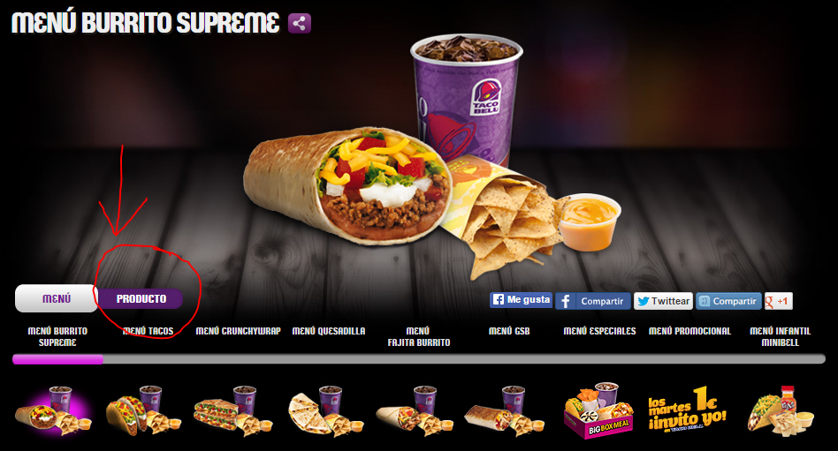

Click the items on the scroll bar at the bottom. Then, navigate through the items using the arrows on the side:
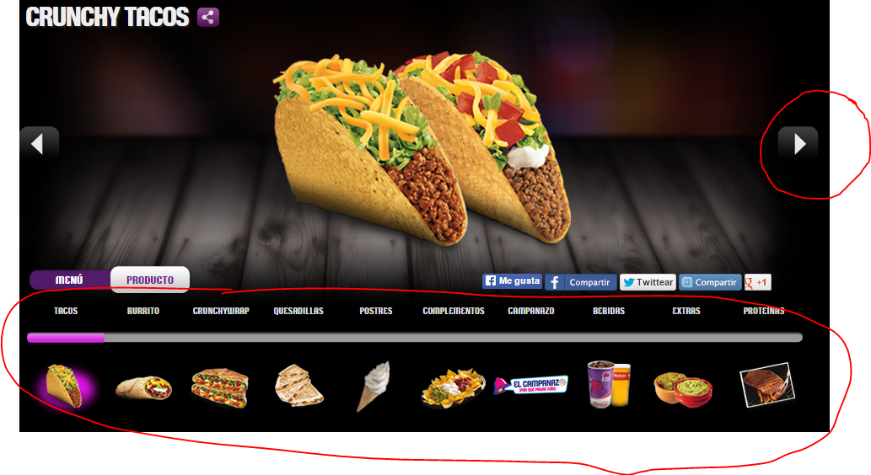
Look at the “complementos”
- What do you think the word “complementos” means?

What are two complementos that we do not have at the Taco Bells in the United States that are at the Taco Bells in Spain?

Look at the desserts. What is one thing we don’t have in the United States that you wish we did?

Look at the social media buttons on the page.
- What is the verb “to tweet”?
- What is the difference between the “me gusta” facebook button and the “compartir” facebook button?

Telepizza in Spain
Go to the Pizza section and scroll down until you find “Pizza Japonesa”. Click on it.
- What kind of sauce does this pizza have on it?
- What do you think “Japonesa” means?
Find the “Pizzalada” in the pizza menu. This is a combination of two words in Spanish.
- What two words do you think are combined to make the word “pizzalada”?
In the Pizza section, click “A tu gusto” and scroll down to look at the ingredient list.
- What does the word “gambas” mean?
- Would you like a pizza with “gambas”?

- What does the word “maíz” mean?
- Would you like a pizza with “maíz”?
Look at the different types of pizzas.
- What is a pizza you would like to try?
- What are some of the ingredients on the pizza that you can pick out?

Reflection
Finish these sentences in relation to the activity we did today.
- Something that surprised me was….

- Something I thought was interesting was…

- Something I wonder about is…

Vocabulary
1.Review the vocabulary for this section. Try to create four sentences using vocabulario de comida!

